**Guide for behaviour one, the disappearing object**

**This behaviour can be used for a variety of purposes such as making a piece of a wall disappear of making the a certain part of the floor disappear in order to make a trap.**

1. **First you should create all the game objects you need, start with a plain by going into GameObject -🡪 3D Object and then selecting plain, go back into the 3D object tab and create two cubes as well, be sure to move the objects around to make it neat**

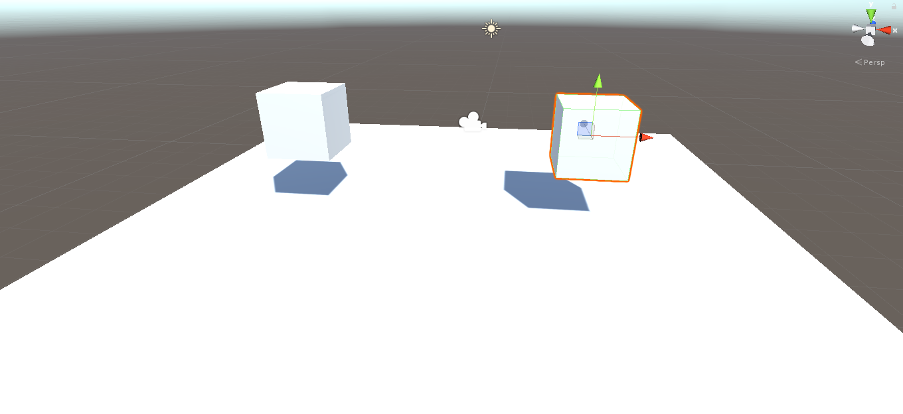

1. **Now to set the objects apart you should change the shape or add a texture to the object, to stretch an object select the scale tool on the top left and use it to stretch or squash one of the blocks. If you wish to add a texture first you should create a material to do this go right click and go Create 🡪 Material and then create the material you want once you’re done you can simply drag the material onto a game object to apply it.** 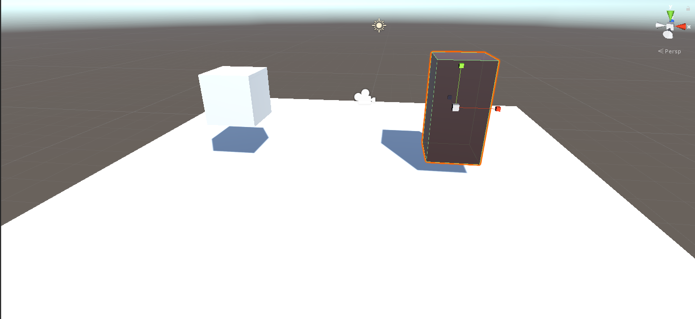
2. 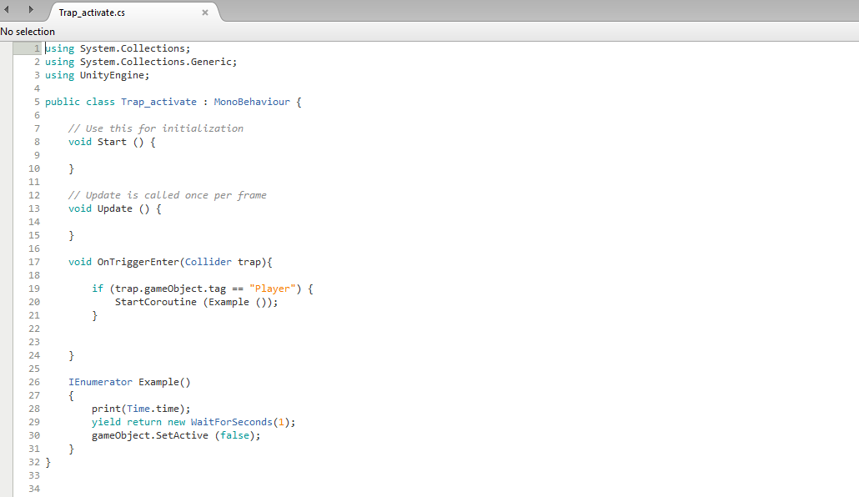**Now we can move onto making a scrip to make the object disappear please refer to the image as I will be explaining what each line of code does.**

This shows the time in the console

And this sets how long it should wait before it actually activates and sets the object to false

This sets the active item to false meaning it disappears.

This part starts the code “Example” which is located here

This part of the line looks for the tag, in this case the tag is Player

This part of the code detects if the object collides or not

1. **Now that the script is ready press F8 to save, you should have the script in unity now, drag the script onto one of the objects that you wish to have disappear when collided, you can drag the script to the game object itself or onto the inspector, once you have done that be sure that “Is trigger” is ticked.**
2. **Now for the other object be sure to add the tag “Player” to it by going onto the inspector and assigning the tag “Player” Scripts which look for the tag player will now activate with that object, be sure to also add a rigidbody to the object as it won’t work otherwise.**
3. **The script should now work, test it out by pressing the play button at the top and dragging the player object into the other object, after a second it should disappear.**